A Remote Pacific Island Awash in Tons of Trash
NY Times By AUSTIN RAMZYMAY 16, 2017
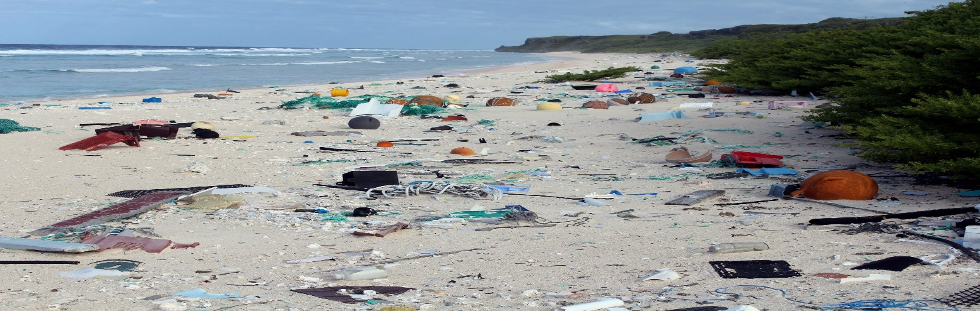
Trash on East Beach, Henderson Island, in the South Pacific Ocean. A new study estimated that the white sand beaches were littered with 17.6 tons of debris, deposited there by ocean currents.

Henderson Island ought to be one of the most pristine places on earth: an uninhabited South Pacific atoll so remote that the nearest human settlement is the small island 120 miles away where the Bounty mutineers hid out.
But the atoll’s white sand beaches are littered with tons of multicolored plastic junk, deposited there by ocean currents.
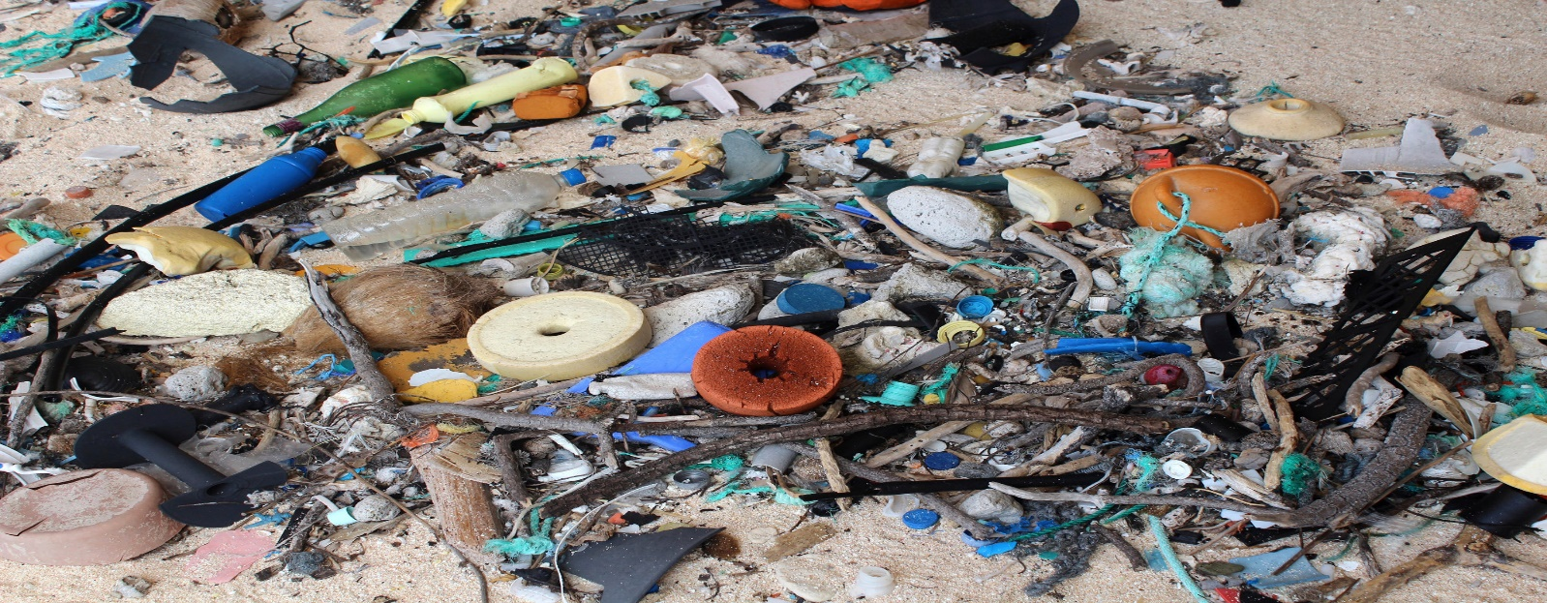
When researchers examined the tiny, uninhabited island in 2015, they counted more than 53,100 pieces of manufactured debris, largely made of plastic — everyday consumer goods that people use without a second thought.
“I’ve been fortunate in my career as a scientist to travel to some of the remote islands in the world, but Henderson was really quite an alarming situation,” Jennifer Lavers, a research scientist at the University of Tasmania in Australia, told the Australian Broadcasting Corporation. The mess on the beach, she said, was “the highest density of plastic I’ve really seen in the whole of my career.”
A new study published in the Proceedings of the National Academy of Sciences by Ms. Lavers and her colleagues estimated that there were 17.6 tons of debris on the shores of the tiny island. The world produces that amount of plastic every 1.98 seconds, the researchers wrote.
When they examined the island in 2015, they counted more than 53,100 pieces of man-made debris, largely made of plastic — bottles, cigarette lighters, fishing gear, all kinds of things. Most of it was buried in the sand, so the problem was even worse than could be seen in photographs of the beach surface.
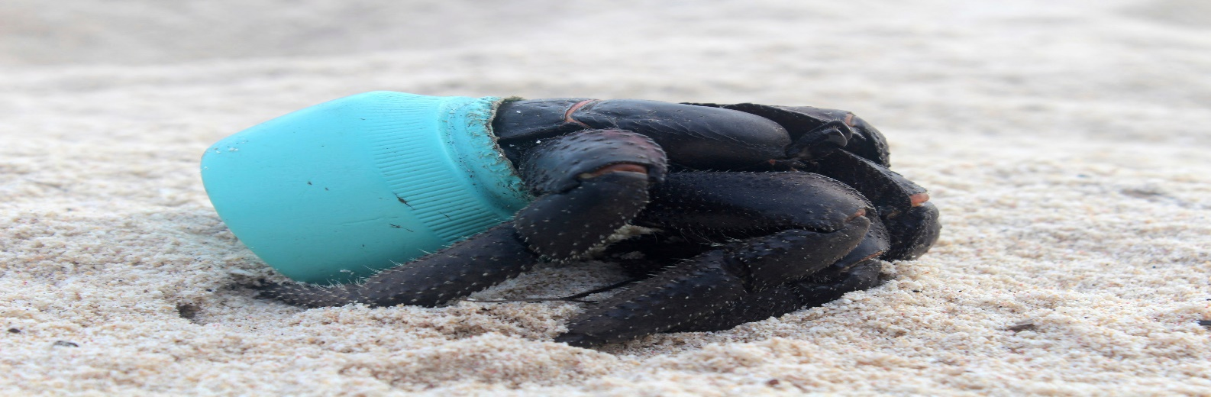
A crab used a piece of plastic debris as a shelter. The growing accumulation of trash has had a clear effect on wildlife on the island.
Henderson Island was named a Unesco World Heritage site in 1988 for its rare ecology, “practically untouched by a human presence.” But the growing accumulation of trash has had a clear effect. The researchers’ images showed purple hermit crabs using plastic containers for shelter, and a female green turtle entangled in a fishing net.
The island, a British possession in the Pitcairn Island group between Chile and French Polynesia, is far from any busy shipping lane. But it sits at the western side of the South Pacific Gyre, a counterclockwise current that collects floating debris from the shore of South America. When the researchers could discern where an item on the beach had come from, it was usually China, Japan or Chile.
The most common items they found were everyday consumer goods that people use without a second thought, Dr. Lavers told the Australian network.
“It speaks to the fact that these items that we call ‘disposable’ or ‘single-use’ are neither of those things,” she said, “and that items that were constructed decades ago are still floating around there in the ocean today, and for decades to come.”

