Debris Science Investigation Kit
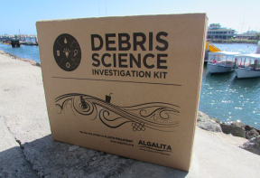Cultivate the inner scientist in each of your students with the original Algalita DSI Kit—a complete curriculum set on the impacts of plastic marine debris customized for one 50-minute period. (Recommended for grades 6-12)
The DSI kit brings real-world science into the classroom and encourages students to develop the same observational skills scientists use to understand the health of our oceans. It is designed to be used “out of the box” with little to no previous science training required on the part of the instructor. In addition, activities may be easily rearranged to fit various curricular objectives and time constraints.

The class period begins with an introductory video focused on the issue of plastic marine debris and its impacts. Students will spend the remainder of the class period rotating among three activity stations, each one focusing on a different scientific concept related to plastic marine debris.
Station 1: Sink or Float
Students explore the different densities of plastic to determine which items will sink or float in sea water.
Station 2: Plastic Soup
Next, they see what can happen to those plastic items once they enter the ocean by analyzing authentic water samples collected from the North Pacific Gyre.
Station 3: Tracking Trash
Lastly, students make critical connections by investigating GIS locations where water samples have been collected.

Each DSI Kit include:
- “Plastic Pollution – The Basics” (6 min video)
- Lab Station Instructions and Materials (3 identical sets)
- Water Samples from the North Pacific Gyre
- Sample Analysis Tools
- GIS Coordinate Clue Cards
- Plastic Debris (for density activity)
- Student Workbooks
- Digital Files of Materials (USB)
- Copy of Captain Charles Moore’s Book “Plastic Ocean”
- Sample Analysis Video
- PowerPoint Presentations

From Algalita.
http://www.algalita.org/youth-education/classroom-tools/debris-science-investigation-dsi-kits-for-grades-6-12/

