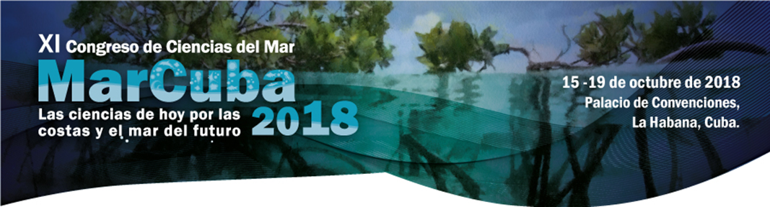

Congress on Marine Sciences MarCuba’2018

Today’s science in the interest of future coasts and seas

October 15 – 19, 2018

International Conference Center, Havana, Cuba

**SECOND** **ANNOUNCEMENT**

***Dear*** ***Colleagues:***

*The National Oceanographic Committee (NOC) of Cuba, along with national marine scientific institutions, is pleased to inform* *you* *that the XI* *Congress on Marine Sciences MarCuba’2018 will be held in October* *5 to 19, 2018,* *at the International Conference Center in Havana.* *Under the motto****“Today’s science in the interest of future coasts and seas",*** *the occasion brings together scientists and other professionals linked to sciences, observation systems, coastal and marine services and technologies, educators, sociologists, economists, businessmen and policy makers* *to attend this important event.*

*The Organizing Committee is sending invitations to various national and international personalities, organizations, institutions and bodies to join us in this eleventh edition of the event that we hope, as in previous years, will achieve a broad participation of professionals from our region and from others as well.*

*Those interested in obtaining information and details onMarCuba'201 8 organization can access the website*[*www.congresomarcuba.com*](https://translate.google.com/translate?hl=es&prev=_t&sl=es&tl=en&u=http://www.congresomarcuba.com) *where you can register for the event.*

*It will be a great pleasure to share with you during the days when the Congress is session and, as usual, give you a cordial and warm welcome to our hospitable country.*

*María de los Ángeles Serrano Jerez*

*President of the Organizing Committee*

**Sponsors:**

* Environment Agency
* National Oceanographic Committee
* Center for Fishery Research
* Center for Marine Research
* GEOCUBA EstudiosMarinos
* National Aquarium of Cuba
* Center for Coastal Ecosystems
* Center forTransportation and Environment Research
* Institute of Marine Sciences
* Institute of Meteorology
* State Task Forcefor Havana Bay
* Hemingway International Nautical Club

**Topics**

**HUMAN IMPACTS AND RISK MANAGEMENT**

* **CLIMATE CHANGE**
* **CONSERVATION AND BIODIVERSITY**
* **BIOTECHNOLOGY AND FOOD SECURITY**
* **MARITIME-RECREATIONAL DEVELOPMENT**
* **Scientific Program**

The Scientific Program of the Congress will be developed in different modalities. Key-note lectures will be delivered by experts of recognized standingat both nationaland international level. It is also planned to develop symposia, roundtables, panels, posterpresentations and some oral presentations that will be selected from the received papers. The presentation modality will be defined by the Scientific Committee in correspondence with the defined topics, the rooms and the time available.

**Working Languages**

The working languages​​of MarCuba'2018  will be SpanishandEnglish. Simultaneousinterpretation will be offered during plenary sessions and in those rooms with greater thematic relevance.

**Instructions for Abstract Presentation**

Abstracts will not exceed 250 words. They will be written single spaced, in letter paper size (8½"X 11"), Arial font type 12 points. The abstract presentation structure is the following: Title of the paper (uppercase and bold), Author(s), Institution, Addressand E-mail. Abstracts may be sent until **June 30th, 2018.** The Organizing Committee will announce the approval of papers on **July 15th, 2018**. Poster size will be 1.20 x 0.80 m, with the following structure: Title, Author (s), Introduction, Objectives, Materials and Methods, Results and Conclusions.

The authors whose abstracts have been approved and are interested in publishing their full papers in the electronic Congress Proceedings shall send them to the Organizing Committee until **September 10th, 201 8**. Specificationsfor the presentation of the full papers are offered below:

No more than 10 pages per paper, including graphics, tables and illustrations. The text will be written in the languages ​​of the Congress: Spanish or English.

1. Assign at least three (3) keywords that reflect the core content of the paper.
2. Letter paper size (8½"x 11") with 2.5-cm margins; justify the text, with Arial font type 12 points single spaced.
3. Size of the electronic document: it should not exceed 1 Megabyte.
4. Structure of the full text: Title (uppercase and bold), main author, co-authors, institution, institutional address, country and email. Next: Abstract, Keywords, Introduction, Objectives, Materials and Methods, Results, Conclusions and Bibliography.

**IMPORTANT** **INFORMATION:**

1. Deadline for abstract submission: **June 30th, 2018**
2. Paper approval publication date: **July 15th, 2018.**
3. Deadline for full text submission: **September10th, 2018**
4. E-mail addressesfor the Congress’Organizing Committee are: [marcuba@acuarionacional.cu](mailto:marcuba@acuarionacional.cu) ; [library@acuarionacional.cu](mailto:biblioteca@acuarionacional.cu)
5. Papers shall be uploaded to the Congress’website **www.congresomarcuba.com** following the procedure outlined on the site.
6. No more than two papers per author will be accepted.
7. Non-acceptance of a paper does not prevent you from participating as a delegate.
8. Participants who require a Letter of Invitation in order to obtain authorization from their institutions, may request it to the OrganizingCommittee. [marcuba@acuarionacional.cu](mailto:marcuba@acuarionacional.cu) ;[library@acuarionacional.cu](mailto:biblioteca@acuarionacional.cu)

**ASSOCIATED** **EXHIBITION** **ExpoMAR’2018**

An Associated Exhibition will be held jointly with the Congress at the Conference Center, which will provide an ideal framework for marine institutions, publishers, production or marketing companies, consultancy firms, and others related to marine topics to show and promote their scientific results, products and services. The price of the modular interior stand is **$ 110.00 CUC per m².**   The location of the stand in the fairgrounds will be determined in accordance with the order of reception of the applications.

**To participate inExpoMAR’2018, pleasecontact:**

|  |  |
| --- | --- |
| **Katia Batista Noa**  Professional Organizer of Fairs and Exhibitions International Conference Center of Havana, Cuba  Phones: (537) 2087541, 2026011 ext. 1507 Fax: (537) 2028382  [katiabatista@palco.cu](mailto:katiabatista@palco.cu) / [www.eventospalco.com](https://translate.google.com/translate?hl=es&prev=_t&sl=es&tl=en&u=http://www.eventospalco.com) | **Selmira Perdomo**  Organizing Committee Marcuba'2018  Environment Agency.  Phone: (537) 2144851  [selmira.perdomo@ama.cu](mailto:selmira.perdomo@ama.cu) |

**REGISTRATION** **FEES of MarCuba'** **2018 /** **IN CUC (CUBAN CONVERTIBLE PESOS)**

|  |  |
| --- | --- |
| Delegates | 200 CUC |
| Pre-graduate students* | 150 CUC |
| Companions | 100 CUC |

**Payment Methods:**

* ONLINE through the website: [www.congresomarcuba.com](https://translate.google.com/translate?hl=es&prev=_t&sl=es&tl=en&u=http://www.congresomarcuba.com)
* Upon arrival in Cuba at the time of accreditation.

* For accreditation, **students** must present an official identification document certifying that they classify for this category, otherwise they shall pay the delegate fee.

**ACCOMMODATION AND RESERVATIONS**

CUBANACAN Travel Agency, official tourist receptor of the Congress, offers different options to the participants, guaranteeing the best rates for accommodation, transportation and other possibilities. For more information, please contact:

Oscar Lopez Betancourt

Market IV Commercial Specialist

International Sales Branch

CubanacanTravel Agency

E-mail: [comercial6.mercado4@avc.vin.tur.cu](mailto:comercial6.mercado4@avc.vin.tur.cu)

[www.viajescubanacan.cu](https://translate.google.com/translate?hl=es&prev=_t&sl=es&tl=en&u=http://www.viajescubanacan.cu)

Phone: (537) 206-9590 to 93 Ext.: 248

**International Sales,** The International Conference Center offers a package especially arranged for the event, which will include: accommodation at Palco Hotel -4* (host hotel), registration fee, accreditation, airport/hotel/airport transfers, activities in the official program and customizedassistance.   Those interestedcan check the link

[http://www.eventospalco.com/es/eventos/MARCUBA2018](https://translate.google.com/translate?hl=es&prev=_t&sl=es&tl=en&u=http://www.eventospalco.com/es/eventos/MARCUBA2018)

**OFFICIAL CARRIER**

Copa Airlines, official carrier of the Congress, offers a 10% discount on the air fare available at the time of purchase. For more details about this and other facilities offered by Copa Airlines, please visit the Congress website [www.congresomarcuba.com](https://translate.google.com/translate?hl=es&prev=_t&sl=es&tl=en&u=http://www.congresomarcuba.com)

**FOR MORE INFORMATION ABOUT THE CONGRESS, PLEASE CONTACT:**

**Organizing Committee**

María Elena Montes,MSc.

Secretary of Promotion

Phone: (537) 2111104

E-Mail: [mariam@acuarionacional.cu](mailto:mariam@acuarionacional.cu)

|  |  |
| --- | --- |
| **International Conference Center, Havana, Cuba**    Katia Iris Medina Reyes, BSc.  Professional Congress Organizer.  Phones:​​(537) 203 8958; 202 6011 to 19 ext. 1511  Fax: (537) 202 8382 E-mail: [katia@palco.cu](mailto:katia@palco.cu)  [www.eventospalco.com](https://translate.google.com/translate?hl=es&prev=_t&sl=es&tl=en&u=http://www.eventospalco.com) |  |

[**www.congresomarcuba.com**](http://www.congresomarcuba.com)

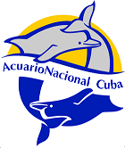

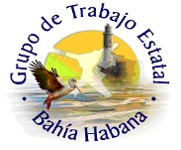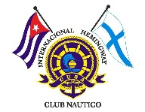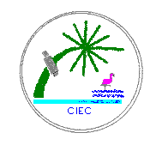

**Descrizione: LOGO Palacio.bmp**