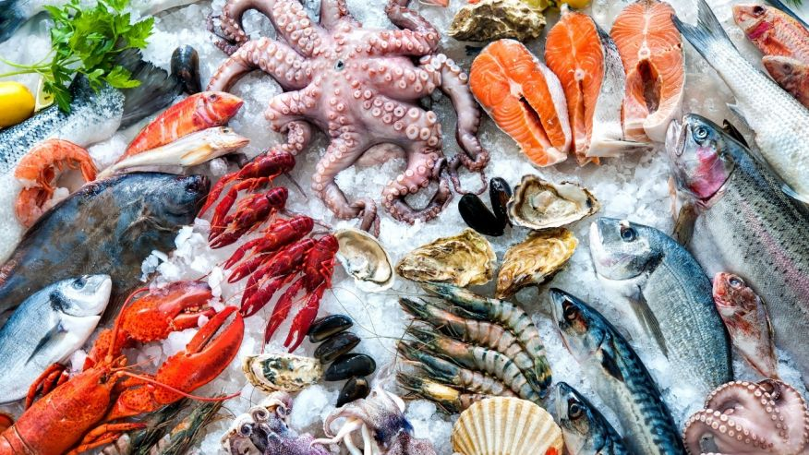

If you eat seafood, you’re eating thousands of pieces of plastic
Seafood fans are ingesting up to 11,000 tiny pieces of plastic a year with unknown health effects, study says.
Ocean pollution is getting ingested by marine life in the form of tiny, toxic microplastics, according to researchers at the University of Ghent in Belgium. And if you eat a lot of seafood, these microplastics will eventually end up in your stomach.
Scientists currently have no clue what type of implications this will have on a person’s health or for future generations.
“Now we’ve established that they do enter our body and can stay there for quite a while, we do need to know the fate of the plastics,” Dr. Colin Janssen, who led the study, told Sky News.
The study showed that humans do pass 99 percent of these microplastics but the remainder gets soaked up by tissues.
“Are chemicals leaching out of these plastics and then causing toxicity?” Janssen said. “We don’t know and actually we do need to know.”

