Microplastics Awareness Activity- Middle/ Elementary

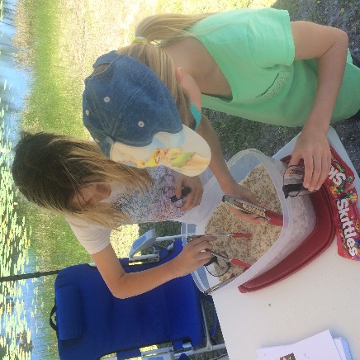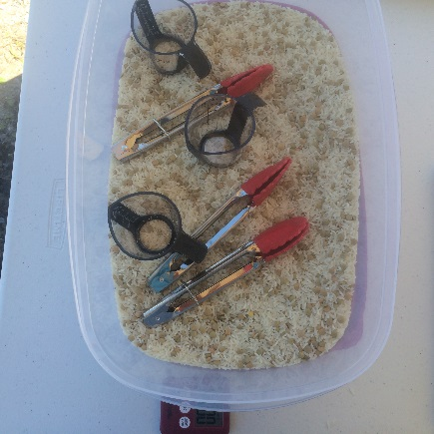
Supplies:
1 container – I used a 12x8x4 inch Rubbermaid container with lid (makes storage easy)
3 small cups – I used small measuring cups with handles
3 tongs – could also use spoons
5 lbs. white rice – represents the edible food
1 lb. brown or green lentils – represents the microplastics
Optional – minute timer, coffee filters, calculator

Activity:
Ask kids to pick what they want to be; a baby fish, baby turtle, or baby seabird. Tell them that they are hungry and their food is the rice “floating” in the ocean (container). Unfortunately, their food is contaminated by plastic (lentils). Their job is to use their mouths (tongs) to put their food (rice) in their stomachs (cups) trying to avoid the plastic.

Option 1: Time the activity. Allow 30 secs or 1 minute to feed. This forces the students to eat fast and will ensure they get some plastic.

Option 2: For older kids, I had them pour their stomach contents into a coffee filter and take it back to their desk. Then, they had to count how many pieces of plastic and how many pieces of rice they had. Then they had to calculate the percent plastic in their diet (# plastic divided by # rice) and if it was over 20%, we said it was a mortality. Of course some kids had put a lot of “food” in their stomachs and were unable to count that much rice, so I had them estimate how much rice and just count the plastic.

Discussion:
Reinforce the notion that many microplastics look just like food to small fish, turtles and birds. When these animals eat the plastic it can make them sick or even kill them. That is why it is important to keep plastic out of the environment.

