Description  REDONDO BEACH DATA LOG SHEET | Sample Collection Date | Sample Collection Location | Sample Filtered by | # of plastic FIBERS seen | # of plastic FRAGMENTS seen | # of MICROBEADS seen | # of pieces of FILM seen | # of pieces of pieces of STYROFOAM seen | Date data entered online
Sample from Sand | 2/4/17 | Outer Harbor Redondo Beach | 1.5 mm | 0 | 6 | 1 | 0 | 21 | 2/10/17
Sample from Sand | 2/4/17 | Outer Harbor Redondo Beach | - mm | 1 | 4 | 0 | 0 | 8 | 2/10/17
Sample from Sand | 2/4/17 | Outer Harbor Redondo Beach | 500 um | 3 | 0 | 20 | 0 | 1 | 2/10/17
Stomach of a Mussel | 2/4/17 | Inner Harbor Redondo Beach | N/A | 0 | 0 | 17 | 0 | 0 | 2/10/17
Sample from Water | 2/4/17 | Inner Harbor Redondo Beach | 100 um | 0 | 0 | 40 | 0 | 0 | 2/10/17

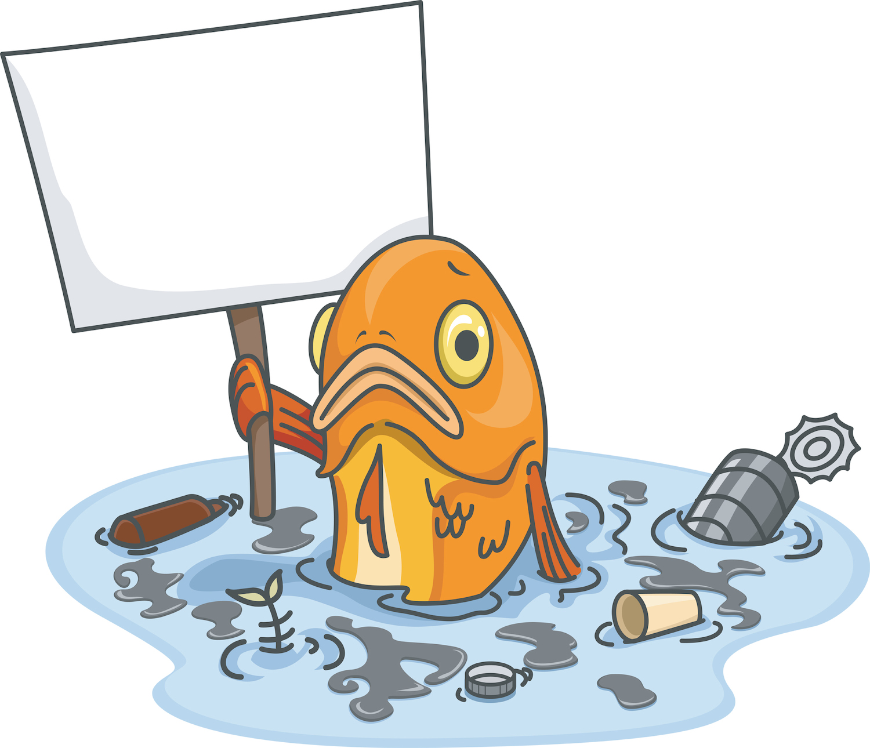
Latitude: 33.8522 Weather: 60°F Wind: 9mph
Longitude: -118.3991 Water Tempt: 51°F Humidity: 82%

Description  DOCKWEILER BEACH DATA LOG SHEET | Sample Collection Date | Sample Collection Location | Sample Filtered by | # of plastic FIBERS seen | # of plastic FRAGMENTS seen | # of MICROBEADS seen | # of pieces of FILM seen | # of pieces of pieces of STYROFOAM seen | Date data entered online
Sample from Sand  Quadrat 1 | 4/6/17 | Dockweiler Beach | 1 mm | 0 | 2 | 11 | 0 | 0 | 4/7/17
Sample from Sand  Quadrat 2 | 4/6/17 | Dockweiler Beach | 1mm | 0 | 1 | 0 | 0 | 0 | 4/7/17
Sample from Water | 4/6/17 | Dockweiler Beach | 500 um | 13 | 0 | 0 | 0 | 0 | 4/7/17

Latitude: 33.9334 Weather: 61°F Wind: 5mph
Longitude: -118.4384 Water Tempt: 59°F Humidity: 69%

