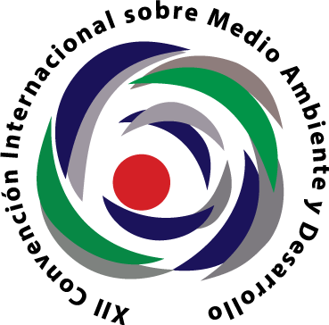
XII INTERNATIONAL CONVENTION ON ENVIRONMENT & DEVELOPMENT

July 1 to 5, 2019 Palace of Conventions of Havana, Cuba "For integration and cooperation for sustainability"

www.cubambiente.com convencion@ama.cu www.eventospalco.com
ANNOUNCEMENT
Dear colleagues:
The Environmental Agency of the Ministry of Science, Technology and Environment of the Republic of Cuba, together with other entities and organizations, has the pleasure of convoking researchers, authorities, educators, specialists, managers, businessmen, professionals, producers and other people from around the world who work for the sustainability of our planet, to participate in the XII International Convention on Environment and Development to be held between July 1 and July 5, 2019 at the Havana Convention Center.

The previous editions of this conclave have reached a participation of more than 9,000 people, of which approximately 50% correspond to visitors belonging to more than 60 countries of the 5 continents.
This edition will promote cooperation among countries, the exchange of experiences and sustainable practices and the transfer of knowledge, as well as sustained and inclusive economic growth, participatory social development, protection of the environment and the dignity of the human being.

It is intended that the debates emphasize, also, the need for the new development agenda to have a universal and integral character, aware that there is no single model or recipe for development.
The Convention will be organized in several events that will cover topics of great validity: XII Congress of Environmental Education for Sustainable Development, XI Congress of Protected Areas, IX Congress of Environmental Management, VII Congress on management of Ecosystems and Biodiversity, VI Congress on Climate Change , IV Congress on Politics, Law and Environmental Justice, VII Symposium of Museums of Natural History, IV Symposium on Sustainability Sciences, III Symposium on Disaster Risk and Climate Risk, I Symposium on Earth Sciences, space and space weather, I Symposium Conservation and sustainable use of marine ecosystems, I Symposium Caves, Carso and Underground Environments, VI Colloquium on Environmental Regulation of the Territory, IV Colloquium Regulation and Environmental Control, IV Colloquium Transport and Environment, IV Symposium on Sustainable Land Management.

In addition, it is presented, as in previous years, the Associated Exhibition Exhibition of Technologies, Projects and Environmental Experiences.

The Organizing Committee of the Convention is pleased to send you this convincing call that your professional contributions will allow reaching the common objectives in a climate of friendship and solidarity. We look forward to your presence.
Attentively
Dr. Maritza García García
Executive President Organizing Committee

The Fair is aimed at promoting, confronting and showing products, services, and technologies linked to environmental protection and sustainable development, which are intended to expose international organizations, government agencies, companies, universities, research centers, service centers , non-governmental organizations, tourism agencies, protected areas, among other entities committed to the construction of a sustainable society through the improvement of relationships with themselves, with the other and with the nature of which they are a part.
At the fair, releases of books and support materials for environmental programs and projects, presentation of sustainable technologies and other initiatives, previously reconciled with the Fair's Secretariat, may be made.

The Fair will be held from July 1 to 5, 2019 in the Main Lobby of the Havana Convention Center.
Conference Themes
• Environmental education for sustainable development
•Protected areas
•Environmental management
• Management of ecosystems and biodiversity
•Climate change
• Politics, law and environmental justice
• Regulation and environmental control
• Natural history museums
• Science of sustainability
• Managing disaster risk and confronting climate change
• Earth sciences, space and space weather
• Conservation and sustainable use of marine ecosystems
• Caves, karst and underground environments
• Environmental regulation of the territory
• Transport and environment
• Sustainable land management
Contactos:
MSc.Selmira Perdomo Sierra, Secretaria Exposición Asociada
Agencia de Medio Ambiente
Tel. (537) 214-4851 E-mail: selmira.perdomo@ama.cu
http://www.ama.cu

