Zophobas morio- Plastic Consuming super-worms
Zophobas morio
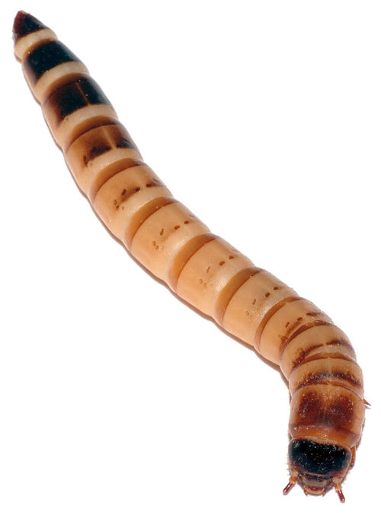
Zophobas morio larva
Common names: | Superworms, Giant Mealworms, Zophobas, Darkling beetle
Life cycle
Egg
↓
Larva
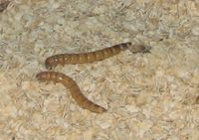
↓
Pupa
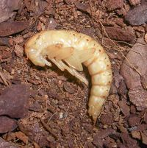
↓
Adult
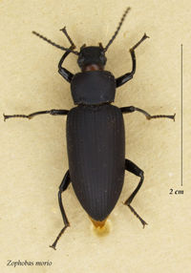
Preparation
Stage consumed: | Larva
Cooking method: | Sauteed, boiled, toasted, fried
Parts consumed: | All
Toxicity: | Potential allergen
Commonly referred to as super-worms, giant mealworms, zophobas, or darkling beetles. Zophobas morio is eaten as the larval stage and is 1.5 to 2 times larger than regular mealworms, at up to 2.25 inches long. The larvae are tan with dark stripes at the end and a dark spot on their head.
The adults are black and have a fused wing plate. Their abdomen is pointer compared to Tenebrio molitor.

Habitat
Super-worms naturally occur in the tropical regions of Central and South America but have spread across the world for use as food for reptiles and other insectivorous pets. They are often found amongst rotting logs and leaves.[1]

Diet
Super-worms are traditionally fed potato, apple, or carrots as a water source in the pet trade since they are easy and cheep to find. keeping them in bran flake or rolled oats as substrate is acceptable for keeping them fed as well as allowing them to burrow and feel safe. Super-worm larvae and their adult form both have been known to accept protein sources like dog or cat kibbles and even dead fish, leaving nothing but tough skin and bones behind. they don’t do well with pure fat or highly fatty food like avocado.

Farming
Obtaining fully grown worms form a pet store can be the cheapest, easiest way to start a colony. Separating the worms into individual isolation containers will insure they pupate into beetles. any worms that haven't curled in to a "C" shape or that don't pupate within 7 -13 days may need to be fed and grow more before being able to pupate. Once your beetles have emerged you may place them into a container of some kind, possibly a storage tub or glass tank with a fine mesh top or many small drilled holes so they can breathe and let out excess humidity. You'll also need to pick a substrate like Eco- earth, rolled oats, bran flake, or even regular soil baked at 350° F for 30 minutes to kill any other organisms living there as a safety precaution. they will also need things to climb on and under. Anything made of cardboard is suitable and cheap enough to discard when it becomes soiled. Once the beetles have gone from brown to black, feed them and provide a moist food than wait for them to mate. once the males climb on to the females and fertilize her eggs, he'll climb off and she will go lay them in the substrate or in a hard to reach place like in between two pieces of cardboard or up agents the wall with her ovipositor. The mating and egg laying process can take a few hours to complete for a single paring of beetles. After about a week or so, the larvae will start to emerge from their eggs, nearly too small to notice in the substrate. Once they grow a to your liking you can sift them out away from the beetles using a colander or mesh box with holes the beetles won't fit through. The beetles will continue to produce offspring along as they aren't too old. Place the beetles back in there container with fresh substrate and repeat the process. Store and let your worms grow out in another container, regularly feeding them oats or bran along with potato or apple for moisture. Use for eating or feeding whatever you are breeding super worms for.
Disclaimer: If you yourself are eating them, the effects of feeding them protein rich food is unknown on how their gut flora affects the human body. All that is known is the super worms themselves enjoy the protein. Also housing them in anything but bran flakes or oats may be undesirable if the larvae are being used for entomophagy as the larvae themselves will eat there bedding. This farming information comes from experiences breeding super-worms for use in feeding reptiles.
Eat at your own risk

